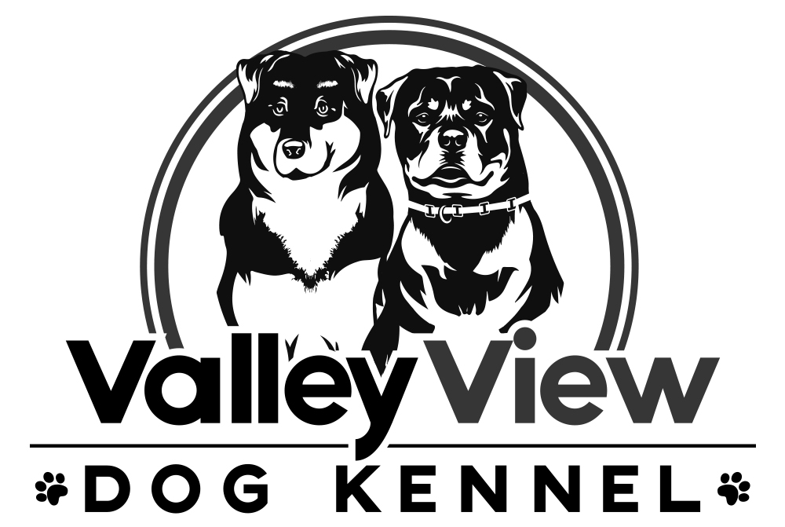

**Medical Release for**

**Valley View Dog Kennel, LLC**

The safety and well being of your dog is our top priority while they are boarding at Valley View Dog Kennel, LLC. We recognize that while your dog is in our care they may exhibit an exacerbation of a chronic illness or develop a new illness that requires immediate attention from a Veterinarian.

* If your dog is deemed to need medical attention while in the care of Valley View Dog Kennel, LLC we will provide transportation and accompany them to the nearest most appropriate Veterinarian facility.
* We will always attempt to contact you or the listed emergency contact, however, if we are unable to get in touch with you or the emergency contact, or we deem the situation to be to emergent to contact you prior to, you authorize transport and treatment of your pet.

I ____________________________ understand that Valley View Dog Kennel, LLC, will seek immediate medical attention for my dog as them deem necessary, regardless of if I am notified prior to transport to an appropriate medical facility. I also agree that I am financially responsible for any medical treatment that my dog receives while under the care of Valley View Dog Kennel, LLC.

Signature of Owner: ___________________________ Date: ___________________________

