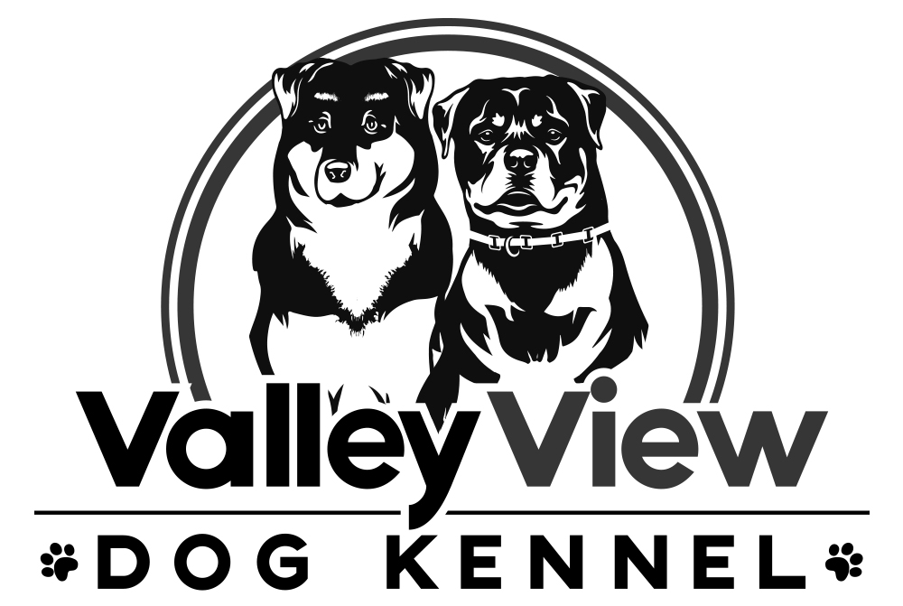

**Boarding Terms and Agreement for**

**Valley View Dog Kennel, LLC**

The health and safety of every dog we board at our facility is our first priority. By signing the terms and agreement, you agree to all terms as outlined below.

* I agree that as the owner, I am responsible for any harm caused by my dog to a human or dog on premises at Valley View Dog Kennel, LLC.
* The dog that is being boarded is lawfully owned by me and is up to date on all vaccinations and has not had a rabies exposure in the last 60 days.
* While not required, it is highly recommended that each dog is on heart worm and flea/tick preventative.
* I agree at the time of drop off, my dog is in good health. All health issues and medications has been disclosed to Valley View Dog Kennel LLC, including surgeries, treatment for illness/injuries, allergies, or special needs.
* I agree, that my dog has not previously shown any signs of aggression and/or bite history that has not been disclosed to Valley View Dog Kennel, LLC.
* If your dog requires medical attention for any reason while in the care of Valley View Dog Kennel, LLC, we will attempt to contact you and the emergency contact listed on the intake form, however, if you are unavailable and we deem evaluation by a Veterinarian is necessary for the well being of your dog, you authorize transportation of your dog to the closest most appropriate Veterinary Facility,. You will be financially responsible for all medical costs.
* I agree that if my dog dies while under the care of Valley View Dog Kennel, LLC, I am financially responsible for all financial costs, and myself or the emergency contact listed will be responsible for making arrangements with our Veterinarian.
* I agree that Valley View Dog Kennel will not be financially responsible for any problems that develop provided that reasonable care and precautions were taken, and I release them of liability of any kind.
* A deposit of _______ is required at time of booking to secure my reservation and is non refundable.
* All outstanding balances need to be paid prior to or at drop off.
* If I decide to pick up my dog early, I will be required to pay for the full reservation as booked and no refund will be provided.
* If I am delayed picking up my dog for any reason, there will be an additional charge of _____ per day per dog in addition to the daily rate.
* I have provided Valley View Dog Kennel, LLC with an emergency contact, who agrees, that if at any point my dog needs medical attention or to be picked up for any reason, they will do so in a timely manner in my absence.
* While we will always try to work through any issues that may arise with your dog that is boarding at Valley View Dog Kennel, LLC, in extreme circumstances, if the issue has the potential to cause harm to us or your dog, you and/or the emergency contact you provided will be required to pick up your dog within _____ hours. Failure to do so will result in an additional charge of _______ per day per dog in addition to the daily rate.
* All food must be supplied by the Owner. We recommend that you bring extra to ensure there is enough. All left over food will be returned to the Owner at pick up. If not enough food is provided you will be charged _______ per day per dog for house food.
* While we will try our best to return all belongings back to you in the condition they were brought in, please note that things do happen, and Valley View Dog Kennel, LLC will not be responsible for replacing belongings.
* We reserve the right to deny any dog boarding at Valley View Dog Kennel, LLC for any reason if we do not feel they are a good fit for our facility.
* I agree that if under state law my dog is deemed abandoned, Valley View Dog Kennel, LLC will proceed with guidelines set forth by the state and I will be financially responsible for all fees associated with this.
* I agree and give permission to Valley View Dog Kennel, LLC to use photographs of my dog, including their name, that have been taken by them for social medial and advertising. Owner information, including last name will never be permitted.

By signing owner agrees to all terms and conditions listed in the pet boarding contract. You also agree that all information supplied is accurate to the best of your ability.

Owner signature: _______________________________ Date: _____________________